1. Introduction
Initially, we sought to answer ‘Do we need a dedicated long-term customer support program or will product updates to improve metric and tool proficiency be sufficient to address the needs of Chronicle customers?’ Upon further deep diving, we discovered that a customer service support team is truly a customer insights team. The customer insights team can use data that currently exists, the data that is received on a daily basis to infer insights that provide each customer a more personalized experience. SPIF sits on a mountain of data used by 30k+ users, 65k+ selling partners, and 30+ automated decisions systems that we are not properly harnessing for generating insights. By harnessing this information and inferring the right insights, there is huge potential here for SPIF to improve its ability to help decision makers drive better decisions, faster, and more accurately.

This paper will cover several topics. First, we will discuss the problem space. Secondly, we will provide an example how a customer service support team is the foundation for a customer insight team SPIF-wide that will leverage customer behavior to generate insights that result in a clear idea of what to focus our current state and how to prepare for the future. Then we will provide a recommendation on how the customer insights team should be implemented, what resources are required, and what implementing innovating hiring sources to help diversify talent, reduce barriers, and hire the best for the positions. But the key to the entire process is the unification of customer data, breaking down departmental barriers, pulling data from differing formats, and eliminating data isolation.

In this meeting, we would like your feedback on our approach and high-level implementation plans. Based on this feedback, we will create a detailed implementation plan.

2. Problem
“People who are 'right a lot' make decisions differently than everyone else” – Jeff Bezos

Despite having parity in terms of access to metrics and analytical tools, there is a gap in how proficient users are in using the metrics and tooling to drive decision. Through different touch-points (e.g., customer SIMs, slack channels, surveys), we have identified that users have varying level of proficiencies that influences the quality and speed of decisions they make (e.g., VM sees a drop in their Net PPM and they are able to look at each component of the Net PPM, and look at shipment and ASIN level data to understand that Sales Discount at specific shipment level is driving the drop thus enabling them to answer a WBR callout and take follow up actions, on the other hand another VM is unable to answer this callout and seeks help from “expert VMs” in their team to understand this drop). This is an example of how institutional knowledge (“expertise”) exists in all parts of Amazon and Selling Partners, which leads to different level of proficiencies. There is a need to systemically collate and distribute this “expertise” to raise the collective bar for decision making in Amazon.
Why can we not use usage patterns to understand customer behavior?
While usage patterns help understand the metrics that users use, they do not help understand the decision flow and the actions taken. Additionally, users often use different tools to drive analysis and actions for a problem. Surfacing information or “insights” based on just usage patterns can lead to incomplete information as it does not always answer critical questions like: 1) why is this important to you, 2) why is this relevant to you, 3) how to use this information. Insights are only complete when you combine quantitative information (e.g., correlation and causation of metrics, impact of specific actions on metrics) with qualitative information (e.g., what issues are important to your business). Usage patterns can help identify quantitative information, but they need to be supported by qualitative information that is available only with a handful of users. Hence, just using usage patterns, will result in incomplete, and often inaccurate insights.

Why should we care about this?
We have an opportunity to tap into Amazon’s expert business strategists and scalably share their insights across relevant Amazonians to drive growth and profitability. Solving this problem will help us create a new (and proven) source for insights, and accelerate proficiency of business users.

3. Net PPM – Turning Customer Support into Insight
In Q4’22, we noticed a high number of customer contacts (5+ SIMs per week) with questions about Net PPM. Previously, our approach has been to answer individual SIMs and resolve them. However, on this occasion, we decided to use an “insights first” approach, where we dove into specific questions that folks had. Through a series of interactions with the individual customers, we realized that most of the questions around Net PPM arose because users did not quite understand the different components and granularities of NetPPM, could not explain changes to Net PPM, and take follow up actions for the same. We then conducted some interviews with experts on how they analyzed NetPPM. Based on these learnings, we created a deep-dive view in Turismo> Analysis to help users understand contributors to change for NetPPM components at ASIN/shipment level and identify any potential actions they can take to address the same. Since launch, this view has been saved by 65+ users in <2 weeks, pointing towards its usefulness. “I have been really impressed by the NETPPM default view in Turismo. It’s extremely useful to look at different Net PPM components and identify driver of change in one single view.” – Luigi D’ Albo, VM
What is our learning from this?
Our key learning is that we can use our customer contacts to identifying emerging issues as well as proactively find solutions to these problems. If we are able to scalably adopt this approach (of using customer contacts/support to generate insights), we can improve proficiency of users in using metrics and tools to drive decisions.

4. Customer Support as Insights Strategy
We have access to 30K+ Amazonians and 65K+ Selling Partners that use our metrics and tools to drive decisions. This access enables us to have insights into their individual decision-making framework, the problems they face, and the actions they take. However, in order to tap into these insights, we need direct interactions with users. By interacting with users when they have problems with metrics and tools, we will be able to spot trends that drive decisions, get a clear idea of what to focus on in the current situation. We propose creating a customer insights team that owns customer support with the goal to: 1) develop a deep understanding of our customers, 2) convert customer anecdotes into insights that can be used to drive improved decisions, and 3) help individual customers answer questions and resolve issues. Figure 1 below describes our customer insights flywheel.
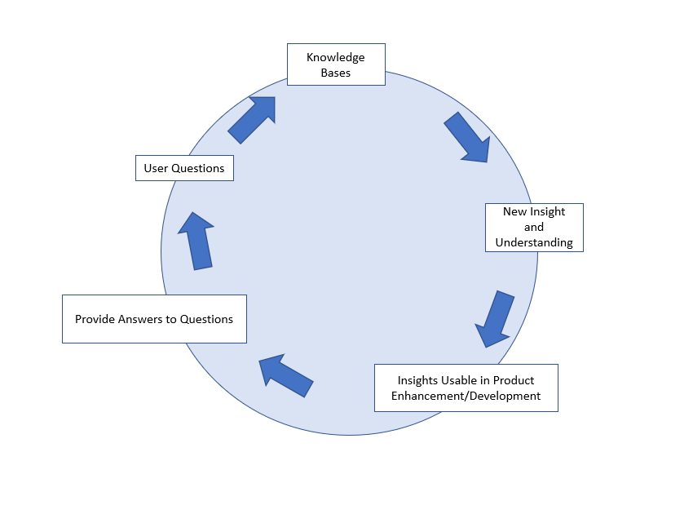
We have identified two pillars for the customer insights team:
- Personalization: Personalization is an effective tool for driving specific behavior that lead to improved outcomes. For a successful customer insights team, personalization manifests in two ways: 1) identifying unique customer behaviors that improve decision making, and 2) understanding when and how to guide customers in their decision-making process. Personalization in this context does NOT mean personalized experiences for users in our applications.
- Centralized information: An effective customer insights team will create and maintain a richly descriptive, unified view of customers, issues, and, potential insights — a view made up of all data types and sourced from all data repositories, irrespective of departmental siloes. This data can be used by tools across Amazon to drive improved efficacy for Amazonians.

Success for this strategy can be measured by its ability to identify new customer behaviors and converting these into insights, relevance of insights generated (personalization), and efficacy improvement for Amazonians through the use of these insights.
What does this mean for our customers?
Through customer interactions, we will be able to identify developing decision-making patterns (use of X metric to solve Y problem) faster and surface this to relevant customers who are currently unaware of this. Thus, we will accelerate decision making for our customers. Additionally, our customers will now have access to information from Amazon “experts” without having to search and scour through multiple sources (like Sage, Merlin), improving their efficacy.

How is this strategy different from what we do today? Why do we need a different strategy?
Our current strategy, revolves around resolving customer issues and the success of our Customer Support is measured based on speed of issue resolution. Our new strategy differs in its inputs as well as outputs (or outcomes). The outcomes for our new strategy is improved insight generation (faster and better) leading to better decision making. In terms of inputs, we currently only see customer SIMs for Chronicle to identify customer issues, whereas with our new strategy, we will use a variety of sources such as SIMs across SPIF, different customer channels (such as slack, email), central sources (Merlin, Sage) to identify customer issues and behavior. Also, currently we do not catalog findings from customer issues and focus on resolving issues as opposed to identifying customer behavior patterns and cataloging them in a central location for easy consumption.

5. Implementation
What will the customer insights team do?
The customer insights team will deliver for five key items to generate and centralize insights:
- Qualitative Research: Monitor customer contacts across multiple channels such as customer SIMs, common slack channels from users, Office Hours, and emails. Additionally, they will also go through other central sources across Amazon such as Merlin, Sage used by Amazonians to answer common questions.
- Quantitative Analysis: In addition to qualitative research, also perform quantitative analysis of product usage, and metric trends that can be overlaid on Qualitative research to generate complete insights.
- Validate: Use surveys, customer feedback (via contact channels) to validate the impact and accuracy of insights. In the long term, they will create a frame work to score/rate insights based on our confidence in their accuracy (this will include factors like past record of the users based on which an insight was produced, past record of insights for similar issues). This will help product owners/users are able to decide the confidence level for these insights.
- Catalogue: Create and maintain a central repository of insights based on the qualitative research and quantitative analysis. This repository can be used by product teams to: 1) educate users on how to better use their metrics and products, 2) inform product decisions/roadmaps, and 3) source business insights based on Unify customer data, breaking down departmental barriers.
- Respond: Develop subject matter expertise on our product and metrics, and will use the central repository of insights to answer customer questions.

How will customer insights team implement personalization?
As a part of their research and analysis, the customer insights team will develop and maintain detailed customer profiles (not at an individual customer level but these are broad categories/buckets) of customers. Factors that will go into developing these profiles include (but are not limited to): 1) phone tool information (e.g. job family, country, level, time in amazon, time in role, etc.), 2) metric usage patterns, 3) type of questions asked across customer contact channels, and 4) type of insights used/consumed in the past. Based on these customer profiles, the customer insights team will tag their insights as relevant for specific customer profile. This will enable us to map relevant insights for the correct user groups.

What are the skills needed for the Customer Insights team?
Customer Insights team members will need to be proficient in two key functional skills: 1) customer research, and 2) data analysis to deliver effectively on their charter. In addition, to these, they need to lean in heavily on showing customer empathy (to ensure we build and maintain trust with our customers while interacting with them through customer contact channels. Finally, while on the job, they will need to develop a deep understanding of our products, metrics, and our customers’ business processes.

What kind of risks do you see?
We see the following key risks in our implementation plan:
Scalability: Given the manual nature of insight generation process, scaling this to span across all our customers, and products will have risks around: 1) need to ramp up the team quickly on our products, customers, and businesses, and 2) need to linearly grow the team to support as Amazon expands. For #1, we will lean in heavily on our existing product and business SMEs to create a dedicated training plan that focuses on aspects that are needed for supporting the customer insights charter. For #2, while we see an initial heavy manual lift to gather information from our customer contact channels, we will create streamlined processes/product changes (e.g., automatically create SIM issue summaries) to reduce this time. Over time, we expect to see the team spend more time in analyzing data vs. gathering information via customer contact channels.
Inaccurate Insights: Given that the basis of our insights is human “expertise”, there is a risk that these insights are inaccurate and create churn amongst users leveraging it (e.g., using a metric for the wrong purpose). We will address this in three ways: 1) Create a validation process (that includes business owners, metric owners) to validate insights before surfacing them, 2) Continually evaluating insights based on usage and user feedback, and 3) Developing a framework to score/rate insights based on our confidence in their accuracy. However, this is a gradual process and we expect the accuracy of our insights to improve over time.

What is your approach to implement this?
We will experiment this with a small set of customer group for PBMS determine success based on: 1) accuracy of insights generated, 2) impact of insights generated (business impacts, NPS score improvements, reduction in customer contacts for common issues), and 3) time taken to generate insights. Once successful, we will create a roll out plan for this across SPIF, and finally, for other partner tech teams like ARA, ISS, Business Reports.

5. FAQs
- What kind of insights will the Customer Insights team generate?
Metric Insights: These are insights that help in making users more proficient in using metrics. These could be qualitative in nature (e.g., X metrics should be used in Y use cases) or quantitative in nature (when X metric reduces by Y due to changes in A, B, and C metrics) or a combination of both (e.g., during Prime day only X metric increases by Y when A metric drops by B). These insights can also inform metric owners on how they can improve their metrics (e.g., X metric has a lot of questions because the metadata is not updated, X metric is not being used by your target group because they have found an alternative metric).
Business Insights: These are insights that help in informing users about specific actions that they can take to improve their business (e.g., you should do X action to get Y outcome).
Product Insights: These are insights that help in informing users how to better use tools (e.g., use feature X to develop Y tools). Additionally, these also help product teams inform their roadmap and enhancements to be made (e.g., users are not able to use X feature due to Y reason).

- How will you surface insights generated by Customer Insights team?
Customer Insights team is not responsible for surfacing insights. Their charter is limited to generating, and maintaining insights. However, as a part of Chronicle, we will surface these insights in different ways based on the type of insights. Some of these are:
- Surface qualitative metric insights in metric metadata to improve users’ ability to interpret and use metrics
- Surface quantitative and quantitative+qualitative insights in Turismo applications
- Surface business insights in Turismo> Home

- How does this fit into Chronicle’s overarching insights vision?
Chronicle’s vision covers the entire lifecycle of insights: 1) Insight creation (Chronicle generated insights), 2) Insight assignment and surfacing (Chronicle generated and Sourced from partner teams), and 3) Tracking actions/impact/accuracy of insight. Insights from Chronicle Insights team will be one of the sources will be supplemented with other sources. Decisions around the other parts of the insight life-cycle (who to surface insight to, how to surface insights, how to track insights) will be outside the purview of Chronicle insights teams.

- Will the customer insights team be in-charge of managing on-call queues for tech teams?
No. Individual tech teams will be responsible for managing their on-call queues.

- What is the benefit (other than insight generation) for customer support?
Customer insights team will be responsible for monitoring and responding on appropriate customer contact channel. This will help improve our responsiveness due to: 1) elimination of need for bringing in multiple experts for complex questions, 2) hyper-focus of customer contact. We should also see improvements in our customer engagement and satisfaction.

5. Next Steps
Based on your feedback today, we will create a detailed implementation plan for the creation of customer insights team which will focus on its capabilities, priorities, and objectives for SPIF. Additionally, it will also include details of implementing a hiring source like the Amazon Return ship Program, Military Pathways Program, Hiring our Heros Programs, etc. to help diversify talent, reduce barriers, and hire the best for the positions.

